Five Foot Two, Eyes Of Blue by Sam Lewis, Young and Henderson

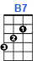
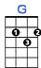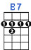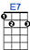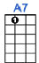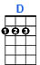

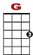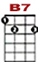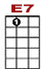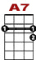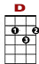

0 0 0 0 3 0 3 0 0
0 3 0 0 4 0 0 0 0 0 0 3 0

Five-foot two, eyes of blue, but oh what those five feet could do, has an-ny-bod-dy seen my gal.

0 0 0 0 3 0 3 0 0 3
0 3 0 0 4 0 0 0 0 0 3

Turned up nose, turned down hose, never had no other beaus, has an-ny-bod-dy seen my gal?

2 3 2 2 3 2 2 0 2 0
0
0 0
4
Now if you run in to a five-foot two covered in fur,

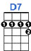
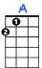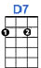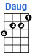

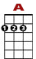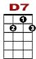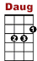

0 2 0 0 2 0 2 5 2 0
3 2 1 3
2

Diamond rings and all those things, betcha life it is-n’t her. But …

0 0 0 0 3 0 3 0 0 3
0 3 0 0 4 0 0 0 0 0 3

Could she love, could she woo? Could she, could she, could she coo? Has an-ny-bod-dy seen my gal?

